

**UNIVERSITY INSTITUTE OF ENGINEERING**

**Department of Computer Science & Engineering**

# Subject Name: MOBILE APPLICATION DEVELOPMENT LAB

**Subject Code:** 20CSP-356

**Submitted to: Submitted by:**

Faculty name: Mr. Hemant Kumar Name: Sahil Kaundal

UID: 21BCS8197

Section: 616

Group: A

**INDEX**

|  |  |  |  |  |  |  |
| --- | --- | --- | --- | --- | --- | --- |
| **Ex. No** | **List of Experiments** | **Conduct (MM: 12)** | **Viva**  **(MM: 10)** | **Record (MM: 8)** | **Total**  **(MM: 30)** | **Remarks/Signature** |
| 1.1 | Installing and running applications on android studio |  |  |  |  |  |
| 1.2 | To design an android application to display Hello World |  |  |  |  |  |
| 1.3 | **Create Application by Using Widgets** |  |  |  |  |  |
| 2.1 |  |  |  |  |  |  |
| 2.2 |  |  |  |  |  |  |
| 2.3 |  |  |  |  |  |  |
| 2.4 |  |  |  |  |  |  |
| 3.1 |  |  |  |  |  |  |
| 3.2 |  |  |  |  |  |  |
| 3.3 |  |  |  |  |  |  |

**Experiment 1.2**

**Student Name:** Sahil Kaundal **UID:** 21BCS8197

**Branch:** CSE (Lateral Entry)  **Section/Group:** 616/A

**Semester:** 6th **Date of Performance:** 16/02/2023

**Subject Name:** Mobile Application Development Lab **Subject Code:** 20CSP-356

1. **Aim:** To design an android application to display Hello World.
2. **Objective:** To design an android application to display Hello World.

Android Studio is the official IDE (Integrated Development Environment) for Android app development and it is based on JetBrains’ IntelliJ IDEA software. Android Studio provides many excellent features that enhance productivity when building Android apps.

1. **System Requirements:**

* Microsoft Windows 7/8/10 (32-bit or 64-bit)
* 4 GB RAM minimum, 8 GB RAM recommended (plus 1 GB for the Android Emulator)
* 2 GB of available disk space minimum, 4 GB recommended (500 MB for IDE plus 1.5 GB for Android SDK and emulator system image)
* 1280 x 800 minimum screen resolution
* Java JDK5 or later version
* Java Runtime Environment (JRE) 6 Android Studio

1. **Steps/Program:**

### **Create the New Android project**

For creating the new android studio project:

1. Select Start a new Android Studio project

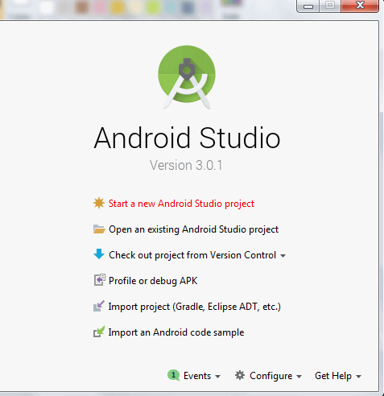

1. Provide the following information: Application name, Company domain, Project location and Package name of application and click next.

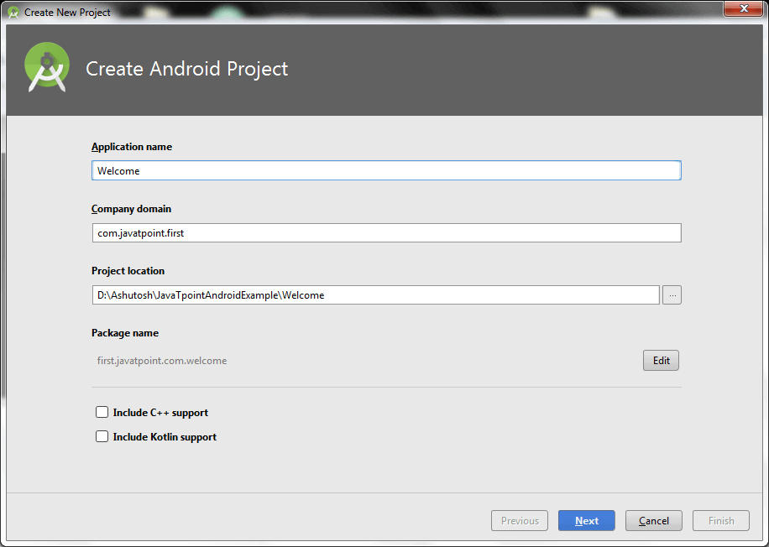

1. Select the API level of application and click next.

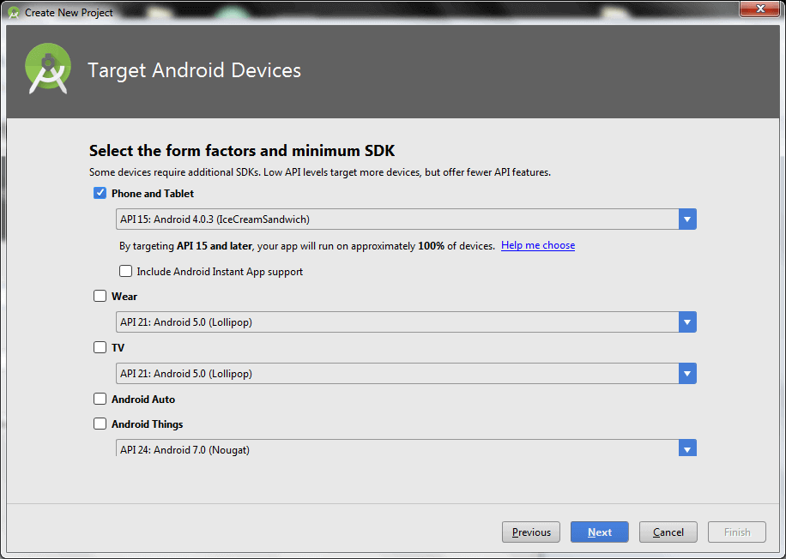

1. Select the Activity type (Empty Activity).

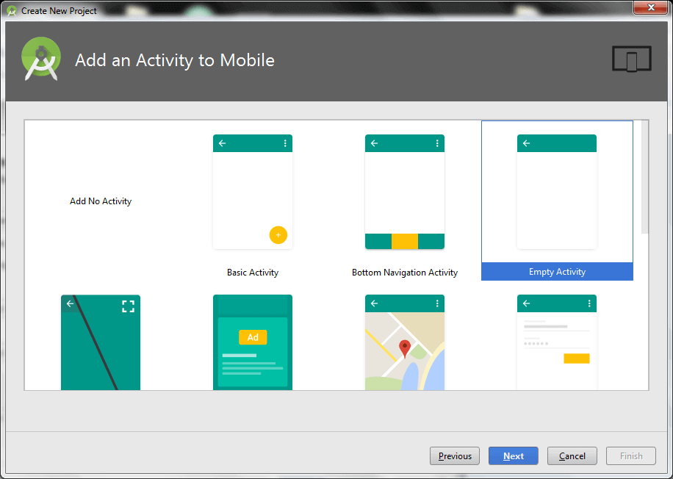

1. Provide the Activity Name and click finish.

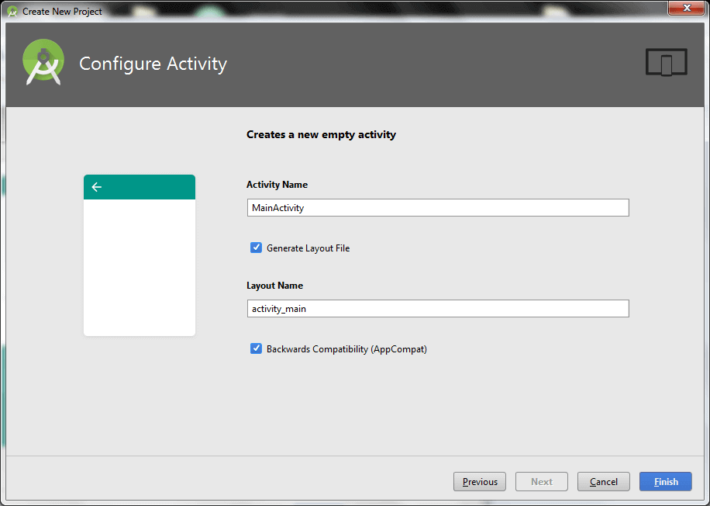

After finishing the Activity configuration, Android Studio auto generates the activity class and other required configuration files.

Now an android project has been created. You can explore the android project and see the simple program; it looks like this:

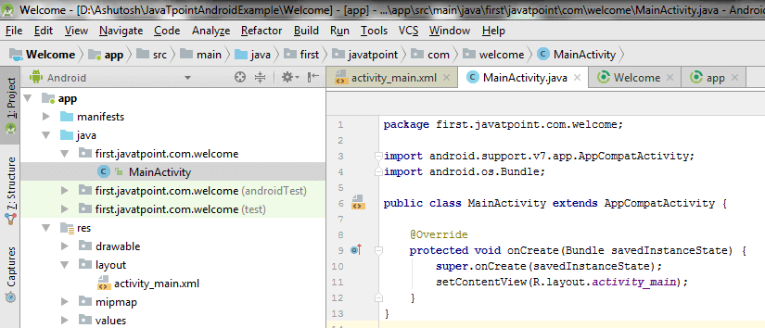

### **Write the message**

***File: activity_main.xml***

Android studio auto generates code for activity_main.xml file. You may edit this file according to your requirement.

*<?xml version="1.0" encoding="utf-8"?>*

*<android.support.constraint.ConstraintLayout xmlns:android="http://schemas.android.com/apk/res/android"*

*xmlns:app="http://schemas.android.com/apk/res-auto"*

*xmlns:tools="http://schemas.android.com/tools"*

*android:layout_width="match_parent"*

*android:layout_height="match_parent"*

*tools:context="first.javatpoint.com.welcome.MainActivity">*

*<TextView*

*android:layout_width="wrap_content"*

*android:layout_height="wrap_content"*

*android:text="Hello Android!"*

*app:layout_constraintBottom_toBottomOf="parent"*

*app:layout_constraintLeft_toLeftOf="parent"*

*app:layout_constraintRight_toRightOf="parent"*

*app:layout_constraintTop_toTopOf="parent" />*

*</android.support.constraint.ConstraintLayout>*

*}*

***File: MainActivity.java***

***package****first.javatpoint.com.welcome;*

***import****android.support.v7.app.AppCompatActivity;*

***import****android.os.Bundle;*

***public******class****MainActivity****extends****AppCompatActivity {*

*@Override*

***protected******void****onCreate(Bundle savedInstanceState) {*

***super****.onCreate(savedInstanceState);*

*setContentView(R.layout.activity_main);*

*}*

*}*

## **Run the android application**

To run the android application, click the run icon on the toolbar or simply press Shift + F10.

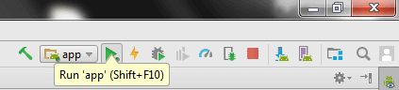

The android emulator might take 2 or 3 minutes to boot. So please have patience. After booting the emulator, the android studio installs the application and launches the activity. You will see something like this:

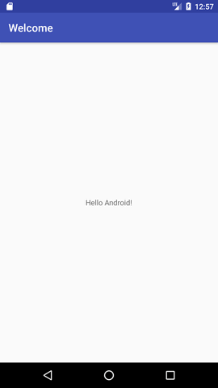

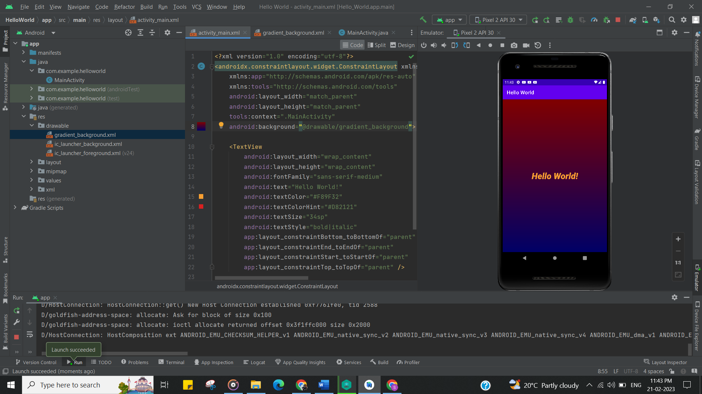

**Learning outcomes (What I have learnt):**

* To design an android application to display Hello World in android studio.
* Learnt about running application on android studio.

**Evaluation Grid (To be created as per the SOP and Assessment guidelines by the faculty):**

|  |  |  |  |
| --- | --- | --- | --- |
| Sr. No. | Parameters | Marks Obtained | Maximum Marks |
| 1. |  |  |  |
| 2. |  |  |  |
| 3. |  |  |  |
|  |  |  |  |